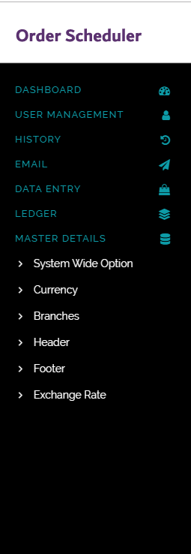

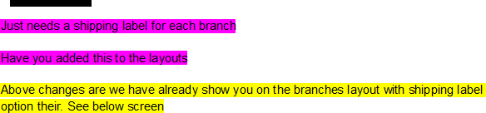

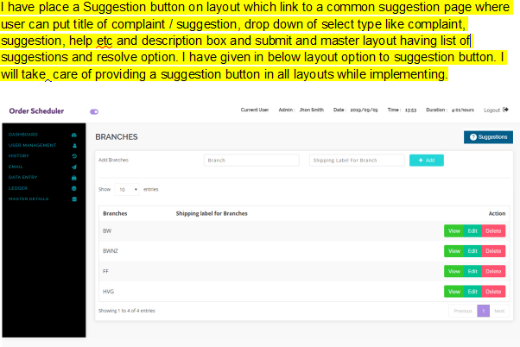

Help Box

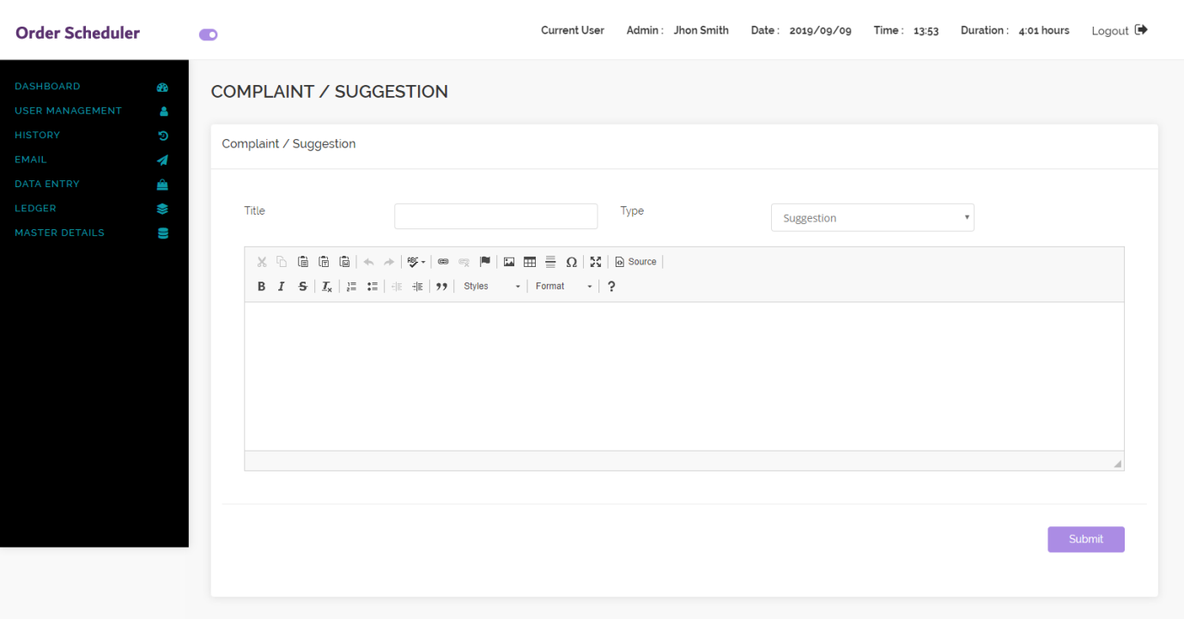

Help List(Master Layout)

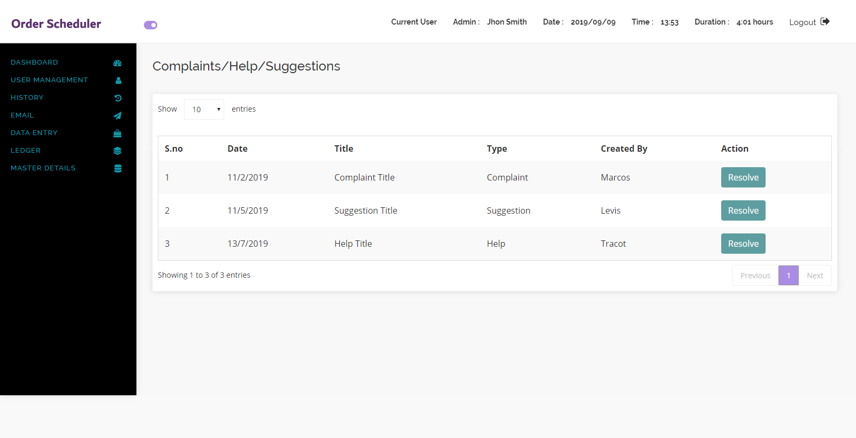

Statement of Account for each branch : is it file upload or just some value to enter in text box?

It is a new ledger that will allow us to search for a client or clients by a date range and sort the data to prepare a statement of what they have paid and ordered

All layouts need the ? help box to write suggestions or to debug by the user

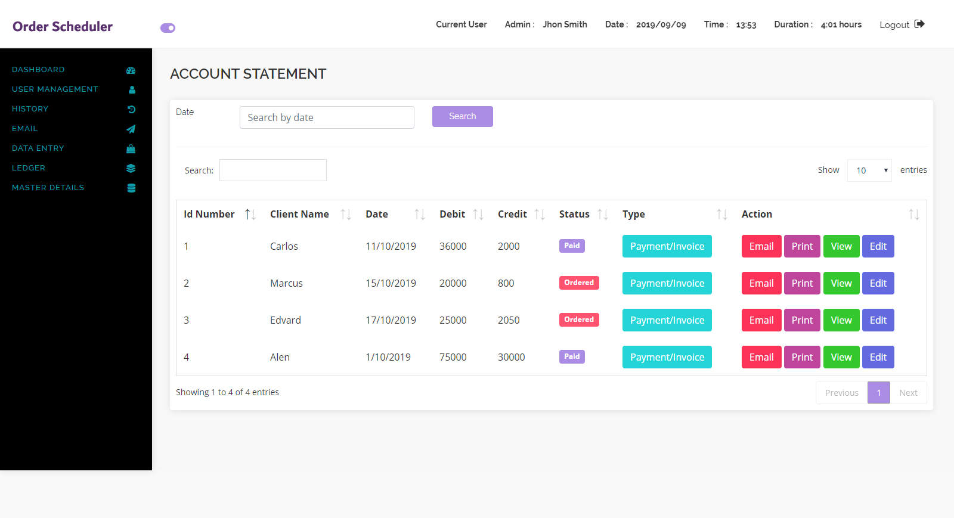

The above form needs these changes

Remove 2nd search box

Add in client name as part of the search or select all clients

Needs an email button which when pressed would provide a statement layout similar to a bank statement

Order Id change to ID Number

Order date change to Date

Needs a credit and debit column instead of order amount

Needs a print button

Needs omit x for each record needs view for each record

Needs a type column that says payment or invoice

Design Approval Form

Order profit form: what should be displayed in this form ? Just fields to work out the overall profit on a job Sales Value minus cost of goods, freight in,freight out, insurance etc?

Also each layout needs a ? section where the user can log a complaint with using the system or a modification.

Q => Please explain more which section do you want to layout? Please

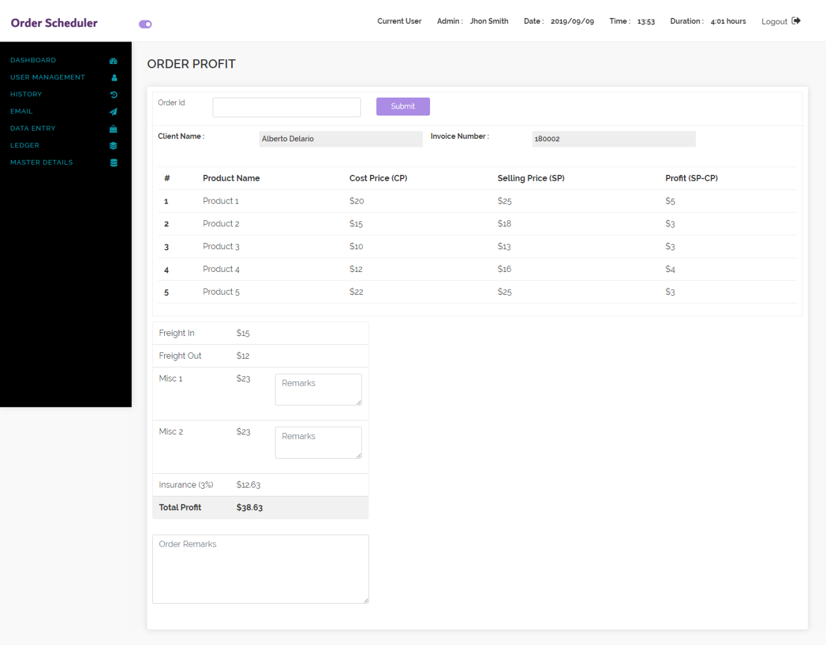

Above form needs

Invoice Number Client Name

Remove freight profit

Add misc 1

Add misc 2

Both of these needs a remarks box

Add another order remarks box

**Branches Approved**

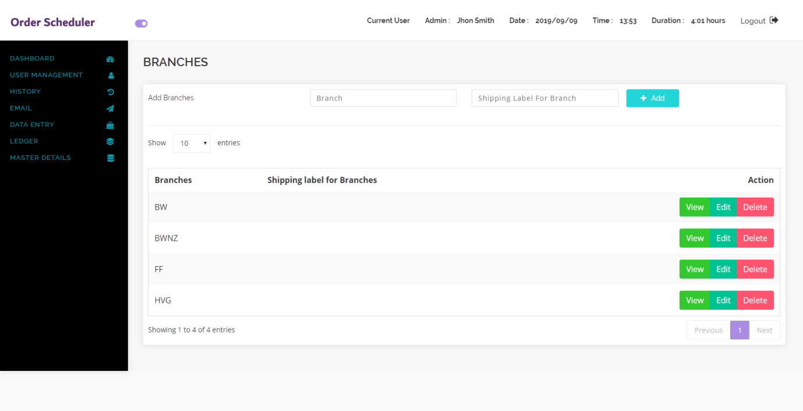

Design Approval This is wrong it would be an email layout that would attach a design and specifications and ask the client to digitally sign and approve

<https://go.docusign.com/trial/productshot-australia/>

Looks ok just functionality

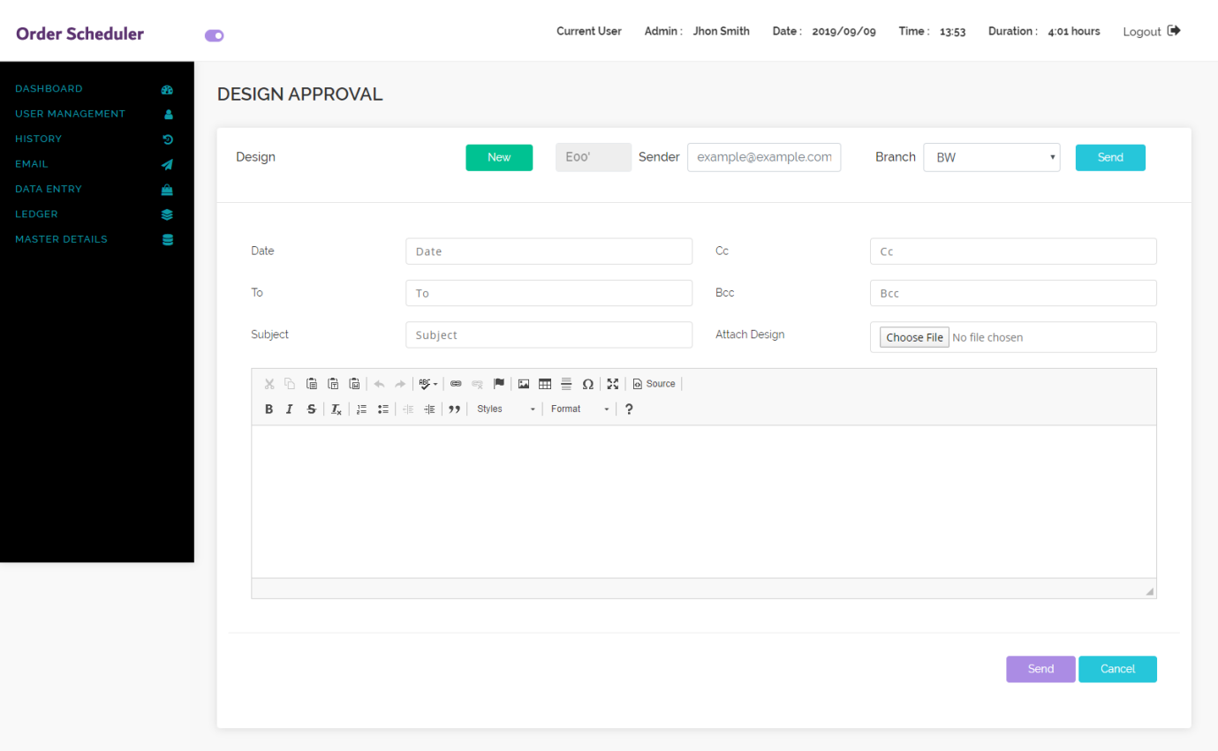

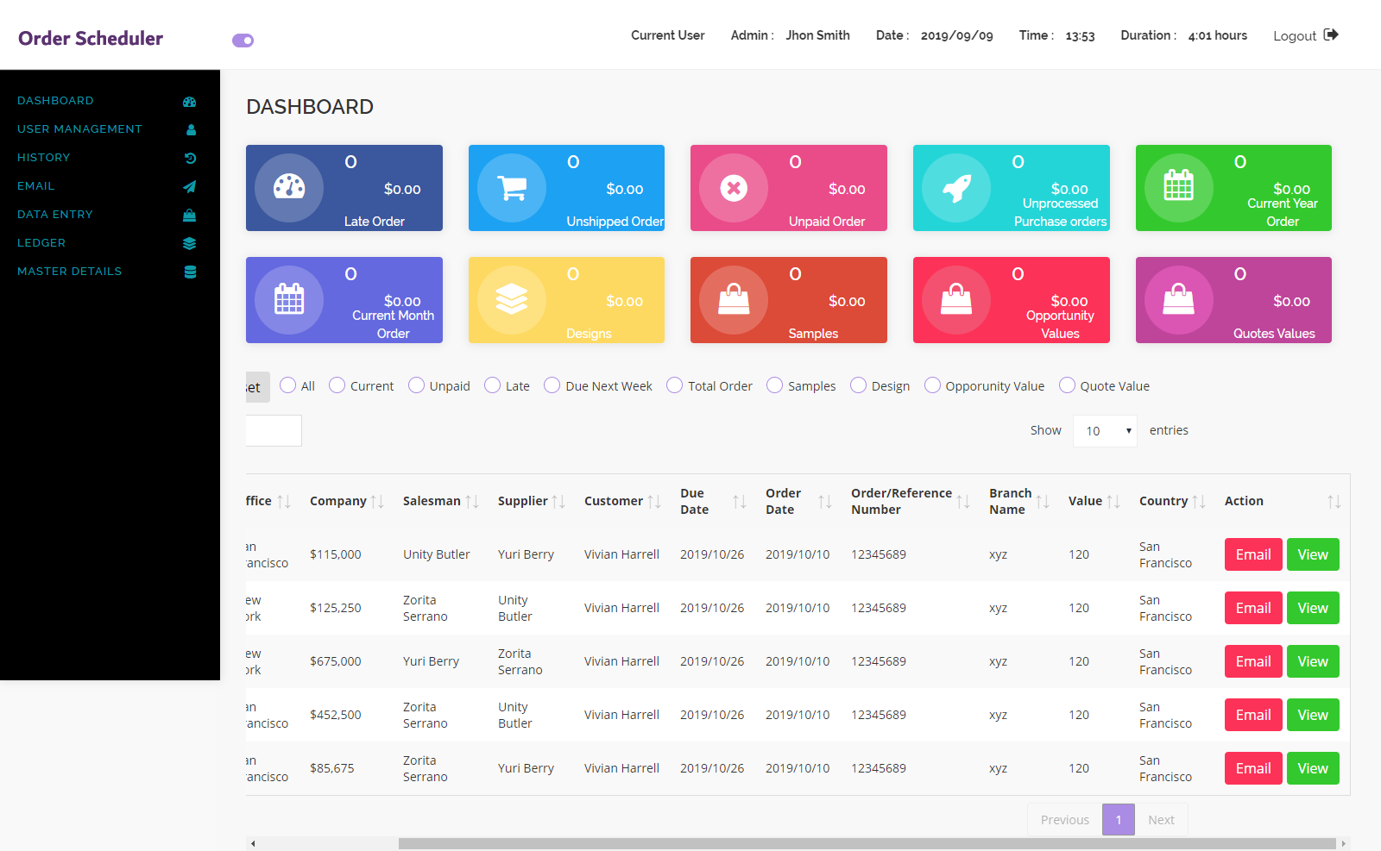

Approved

Just needs a view/email button next to each line

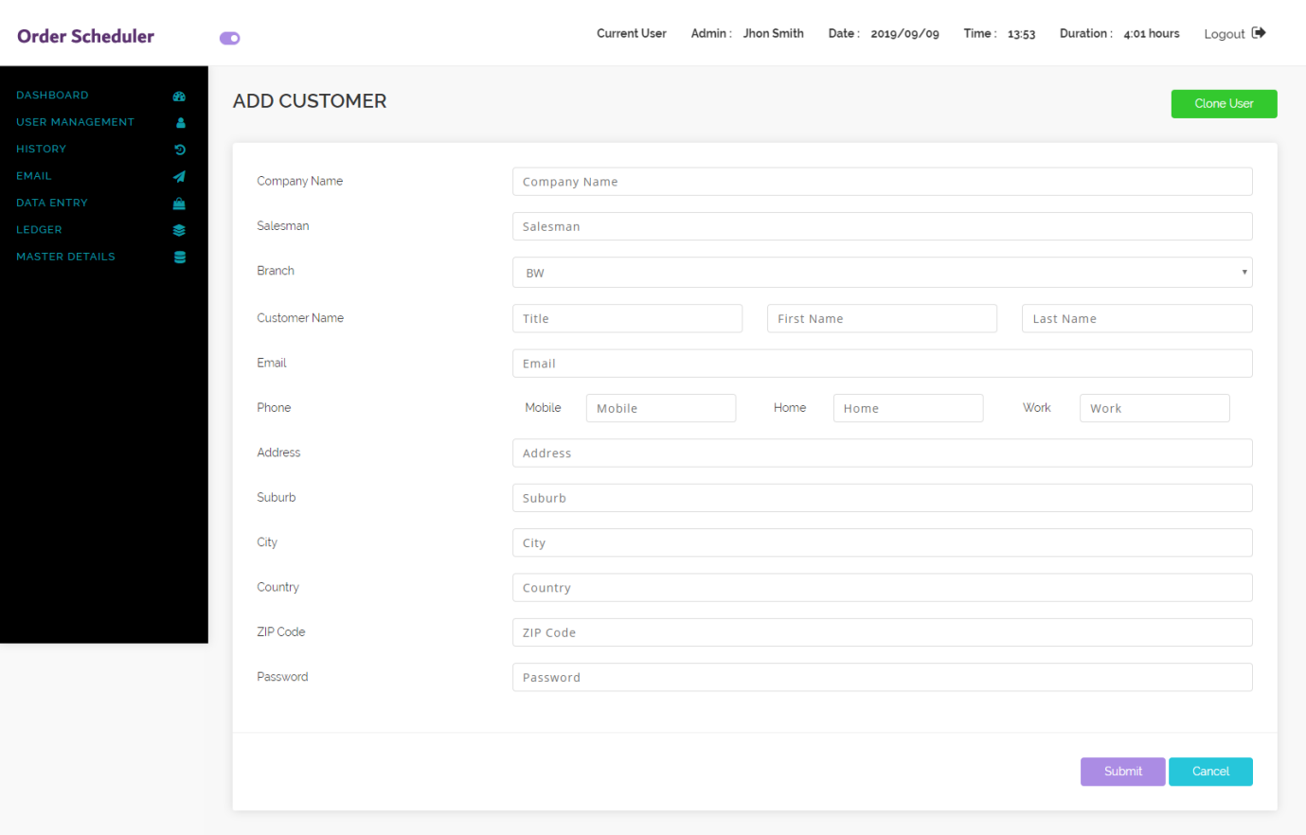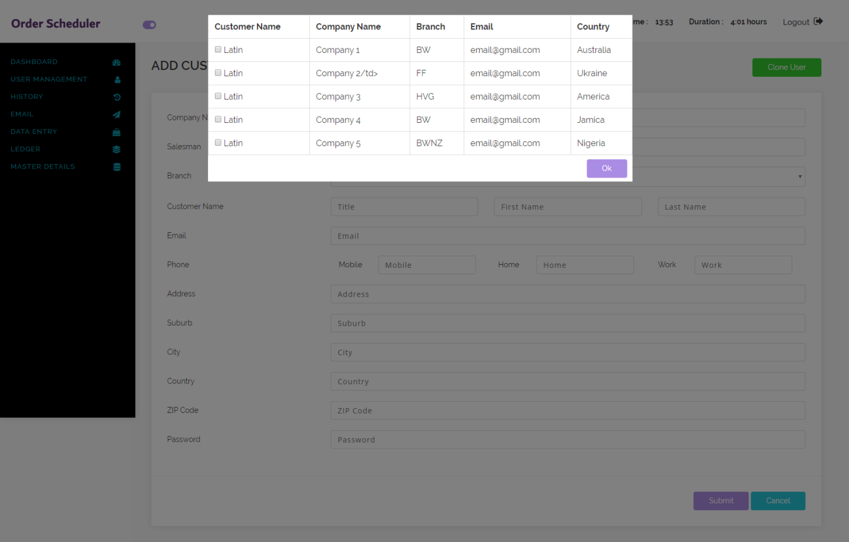

We need to have clone another client? Lookup New or Existing Client?

Move clone user to the top next to add customer and if you click clone user it will pop up a list of users

For the next screen

Its fine but we need to make sure all the fields on the add customer layout are included on this layout

We also need to make sure all layouts are there

And that if a layout is not selected ie that the person is not allowed to view it that the layout field is also unselected and unable to be selected

What is the purpose of the 3 buttons at the bottom ie clone or add another user for the same Company should be the only one button, plus save?

Add another user for the same Company

Add a new user

Save

In the rules can we see the layout for add rules

This is wrong we need the same rules in the master user ie that the user can see certain layouts and fields for the user they are allowed to also see

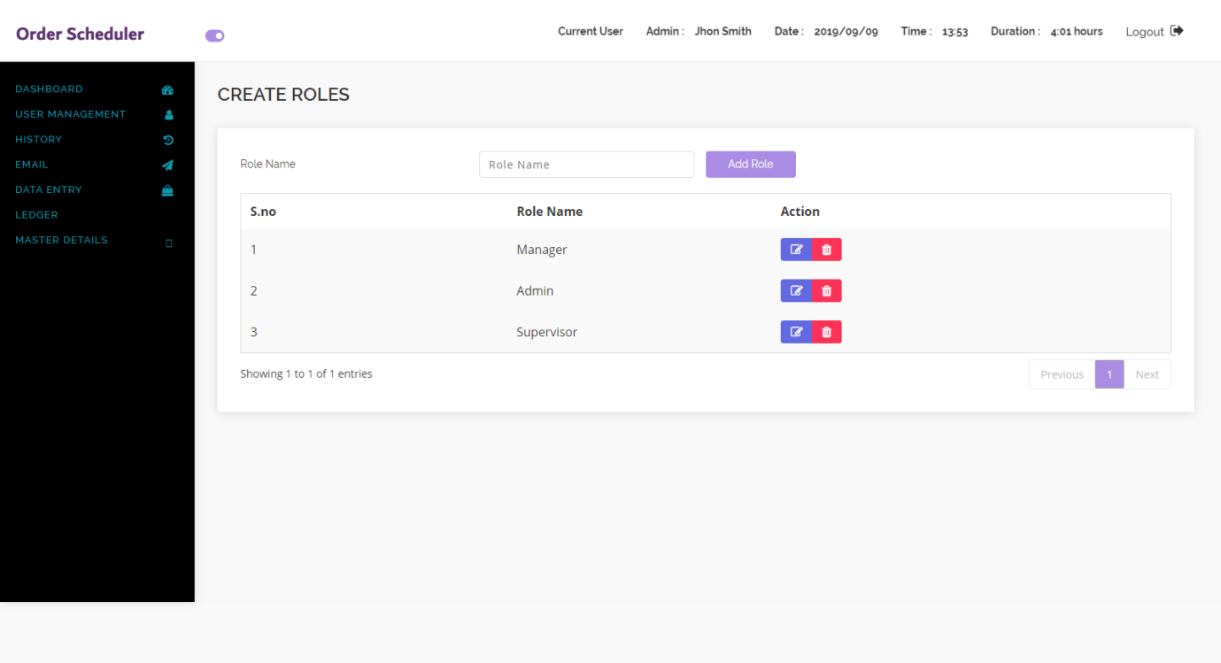

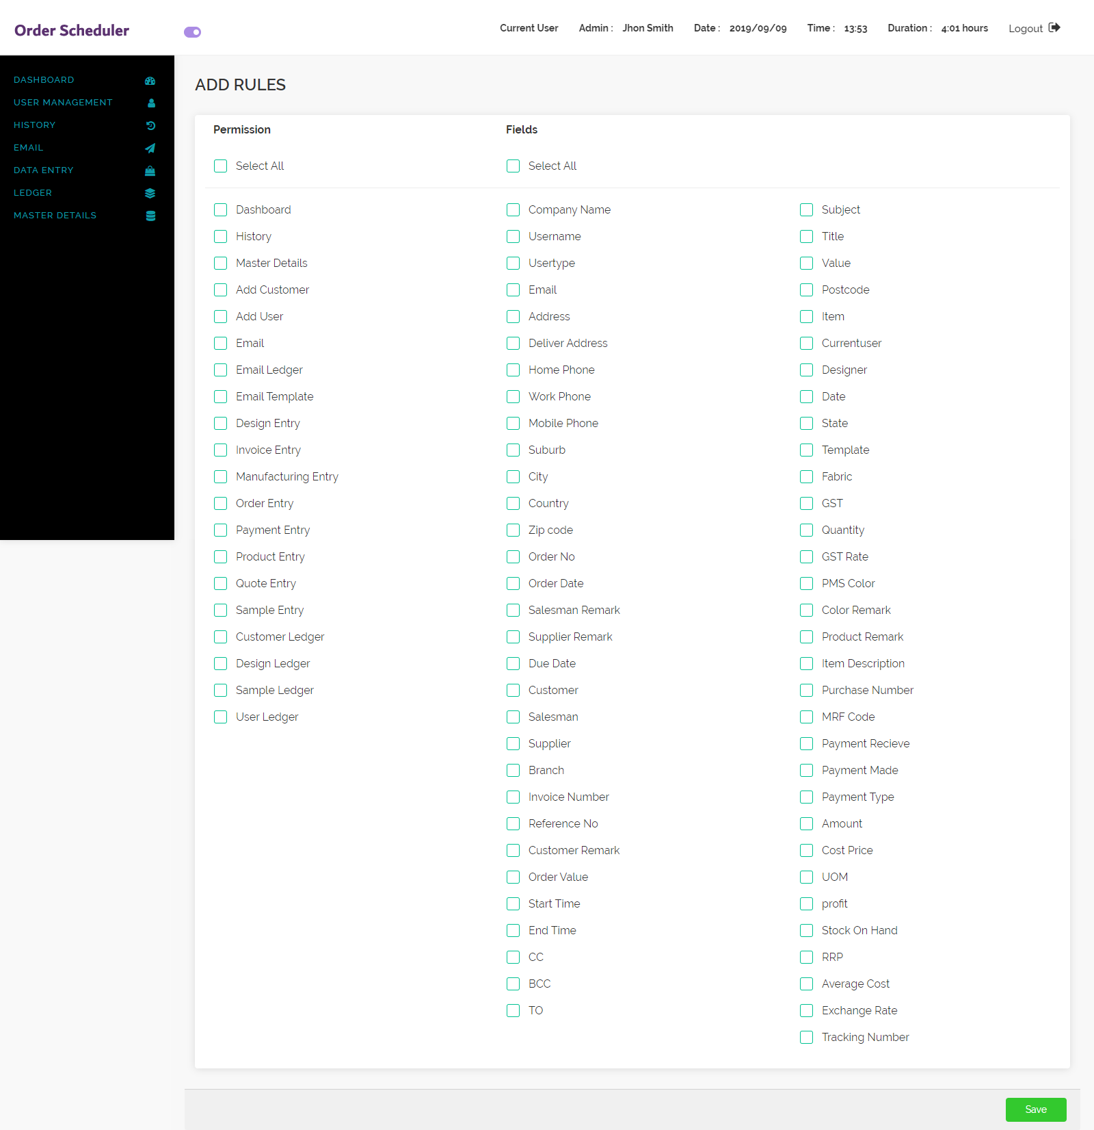

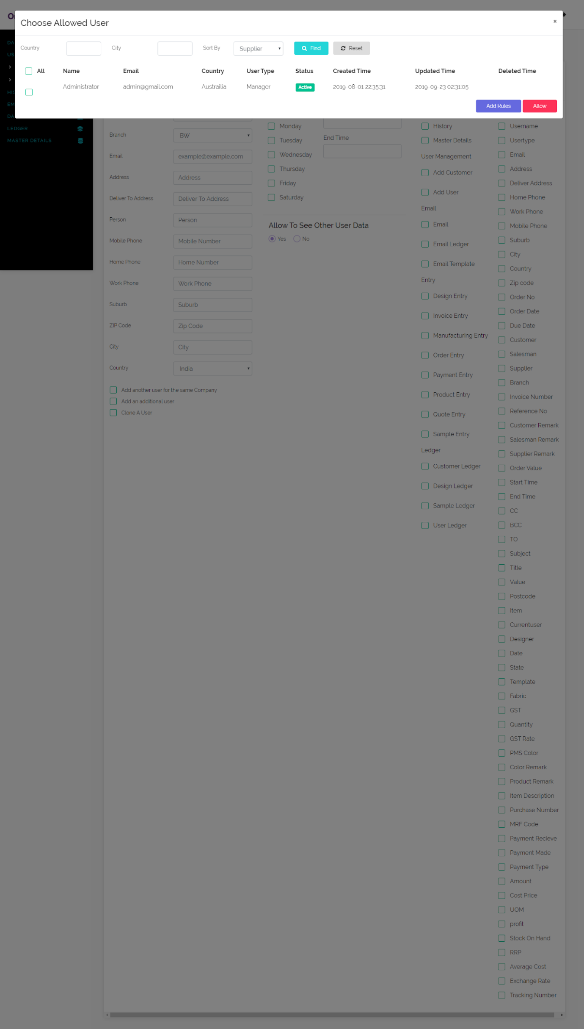

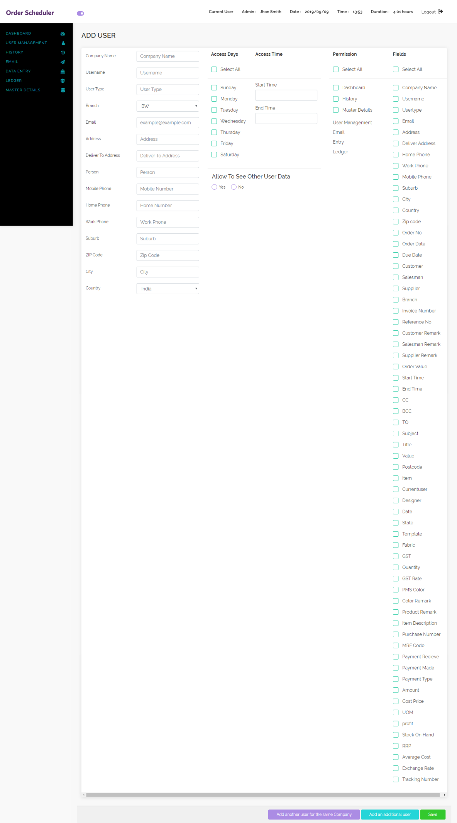

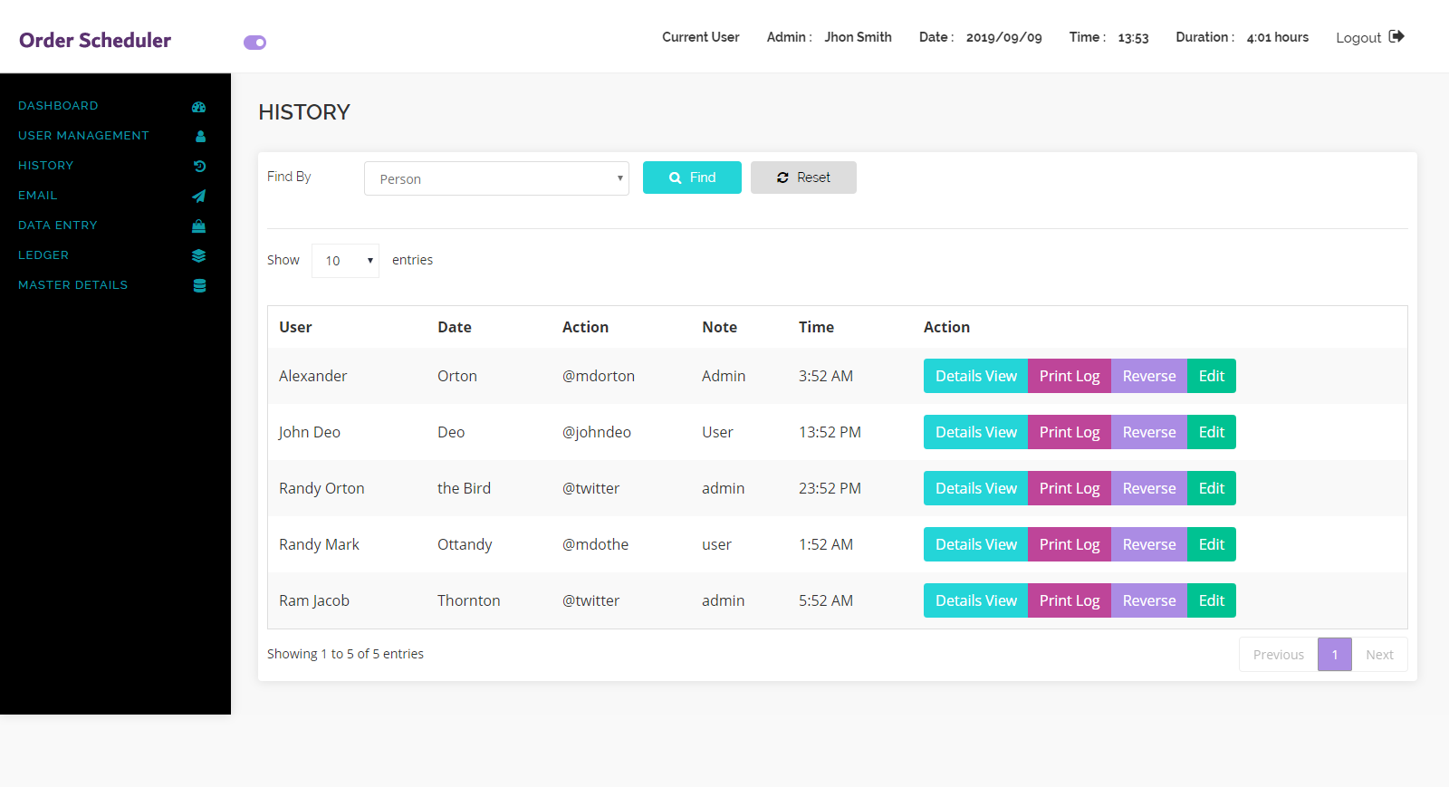

**How do we correct any error in the above layout that we discover**

**I thnk It is dynamic portion of application when any errors logs are stored in database regarding user authentication like wrong user name, invalid email id, wrong password etc add a reverse button OK**

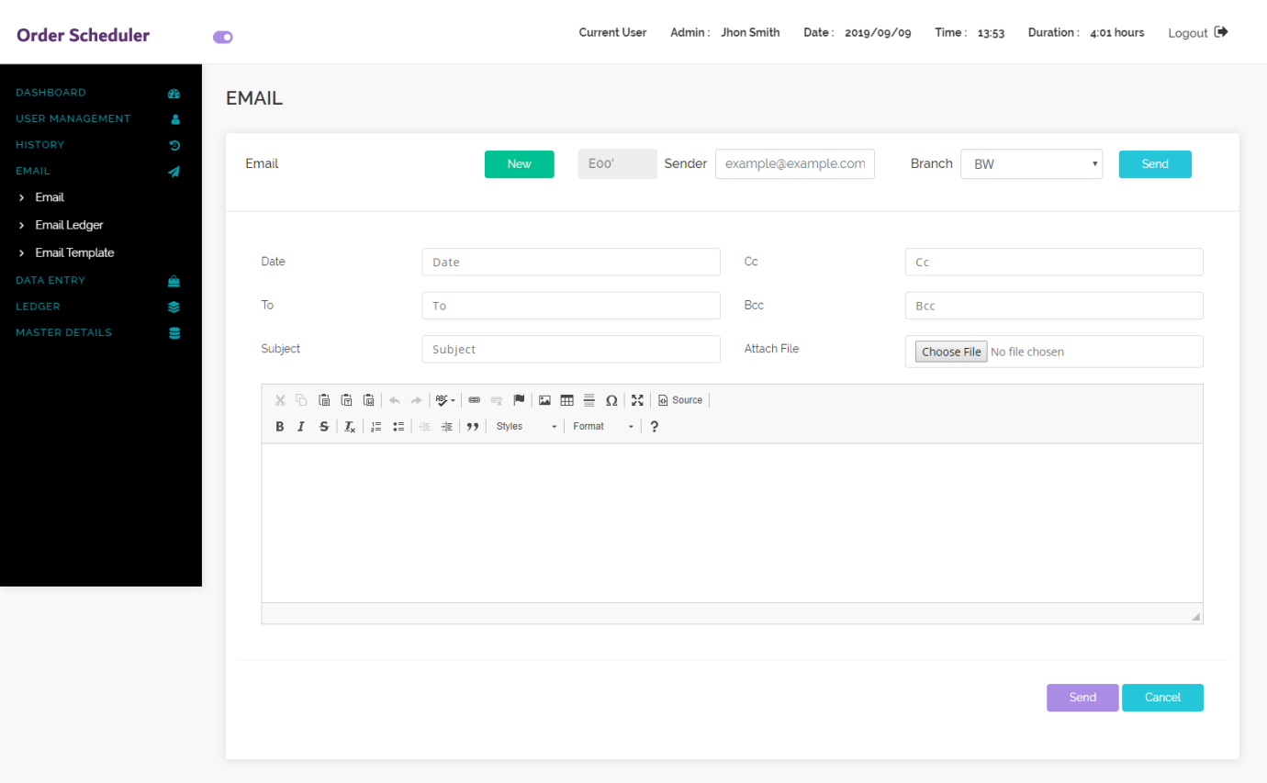

Must link to Gmail or Outlook composer

.

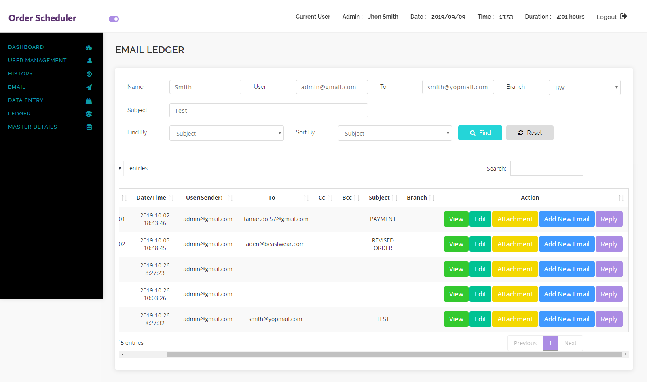

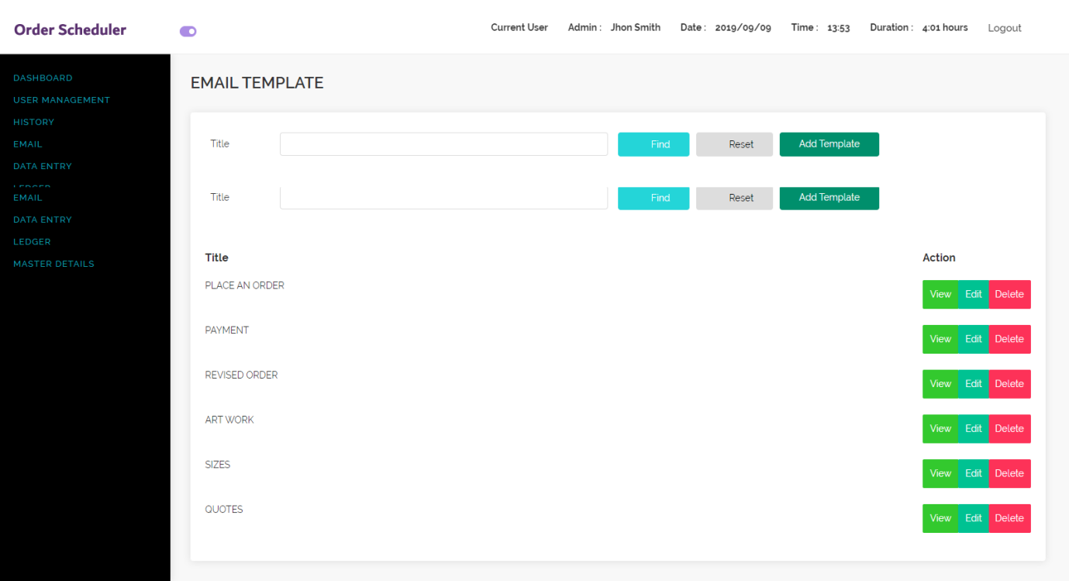

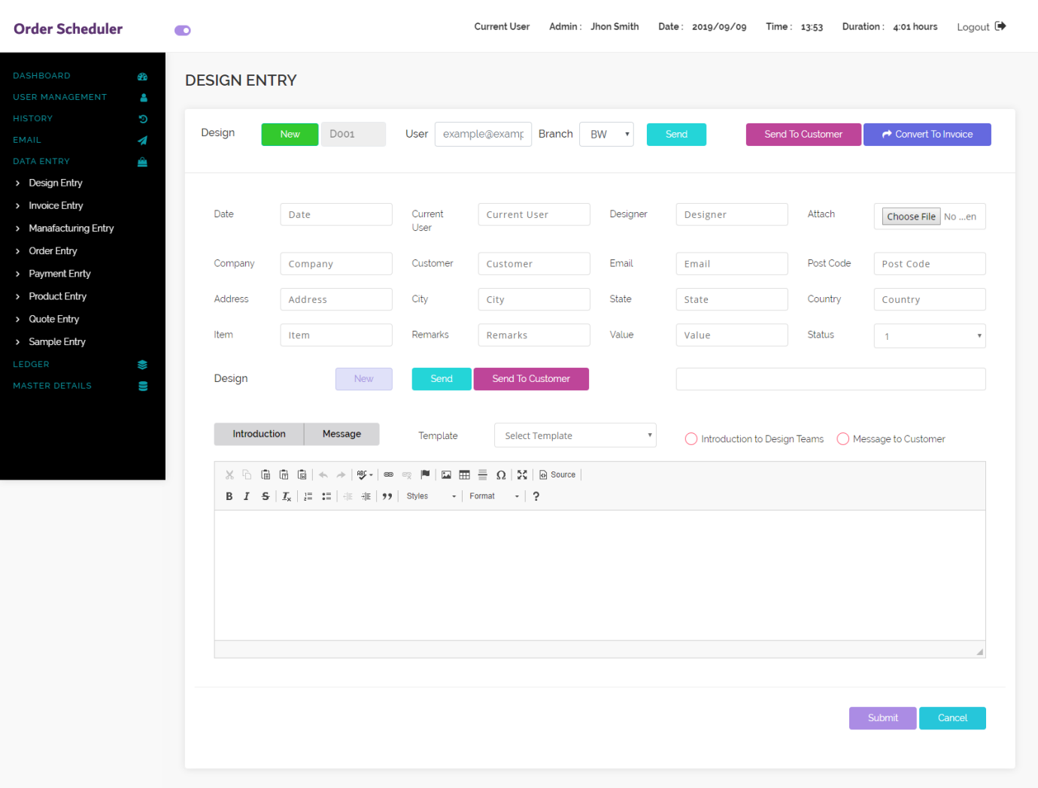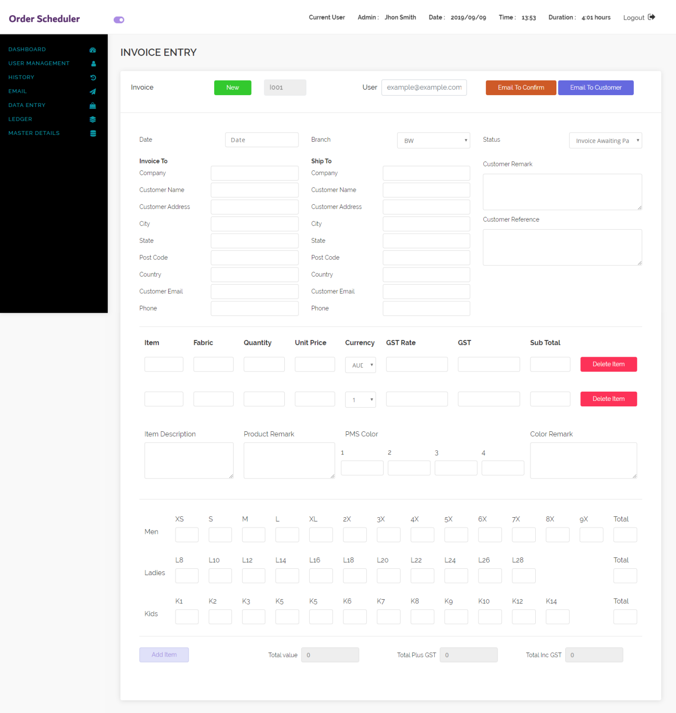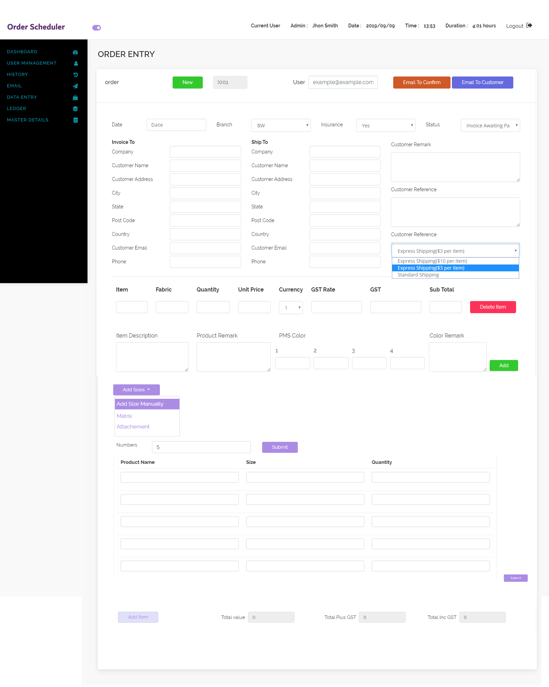++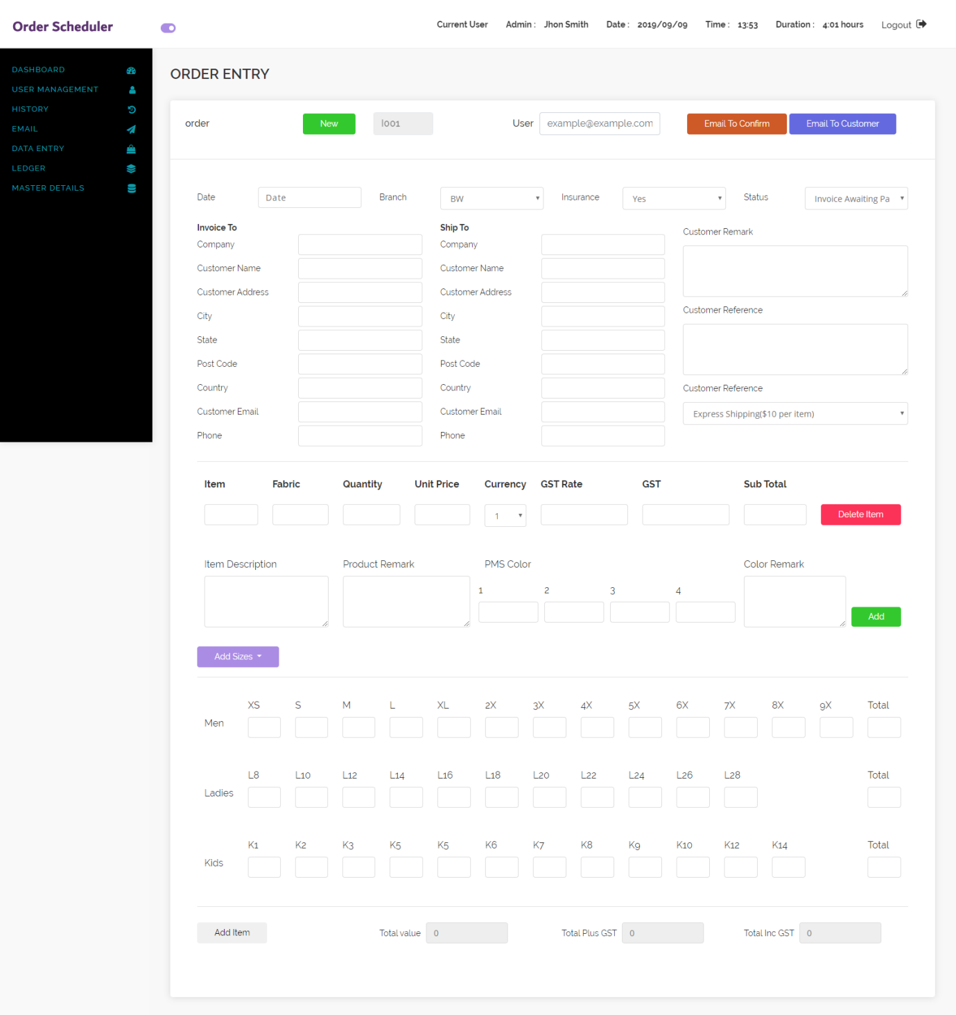

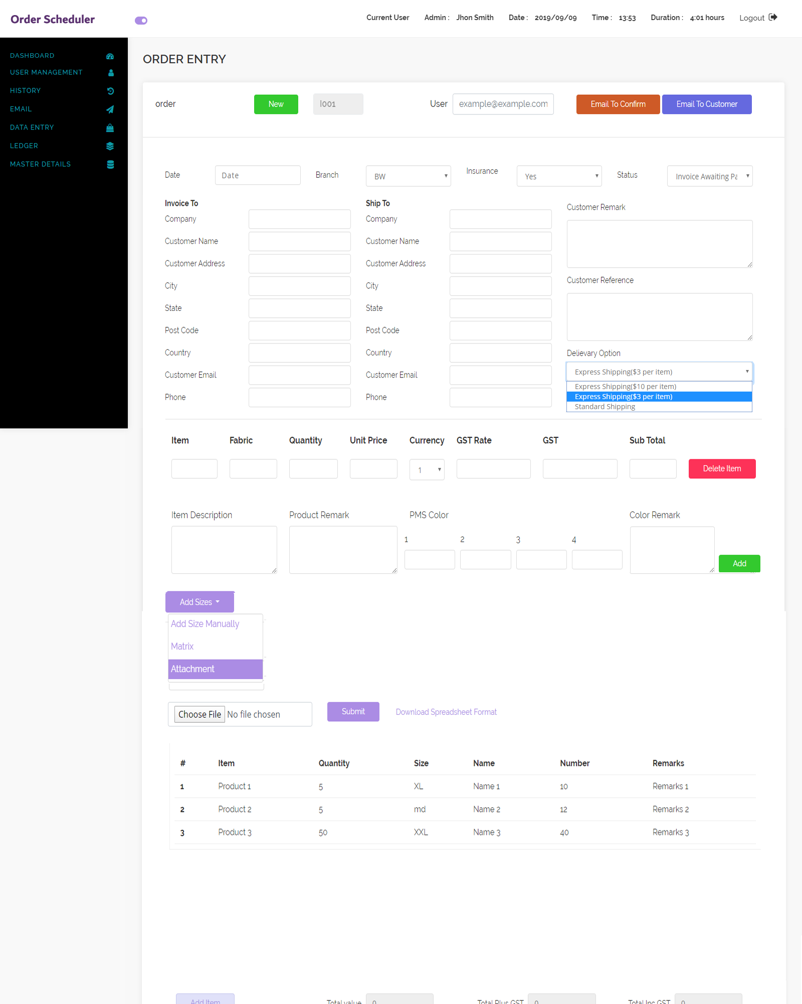

Attachment is spelt wrong

Next to Remarks above add another line button : Please explain more. I am not getting.

Change Express and Standard delivery to Production Next to express +$10 per item

And add a Express +$3 per item and Standard Shipping

**We also need an insurance option ie add insuranc++e**

**Add sizes**

**1.Matrix**

**2.Size text box field plus qty**

**Add names and numbers button**

**spreadsheet with sizes and number and names, this needs a premade excel form to use or**

**an option for a club to attach their own excel form**

**item qty size name number remarks**

**We also need a express delivery or standard delivery option**

**ie add express production standard production**

**We also need an insurance option ie add insurance**

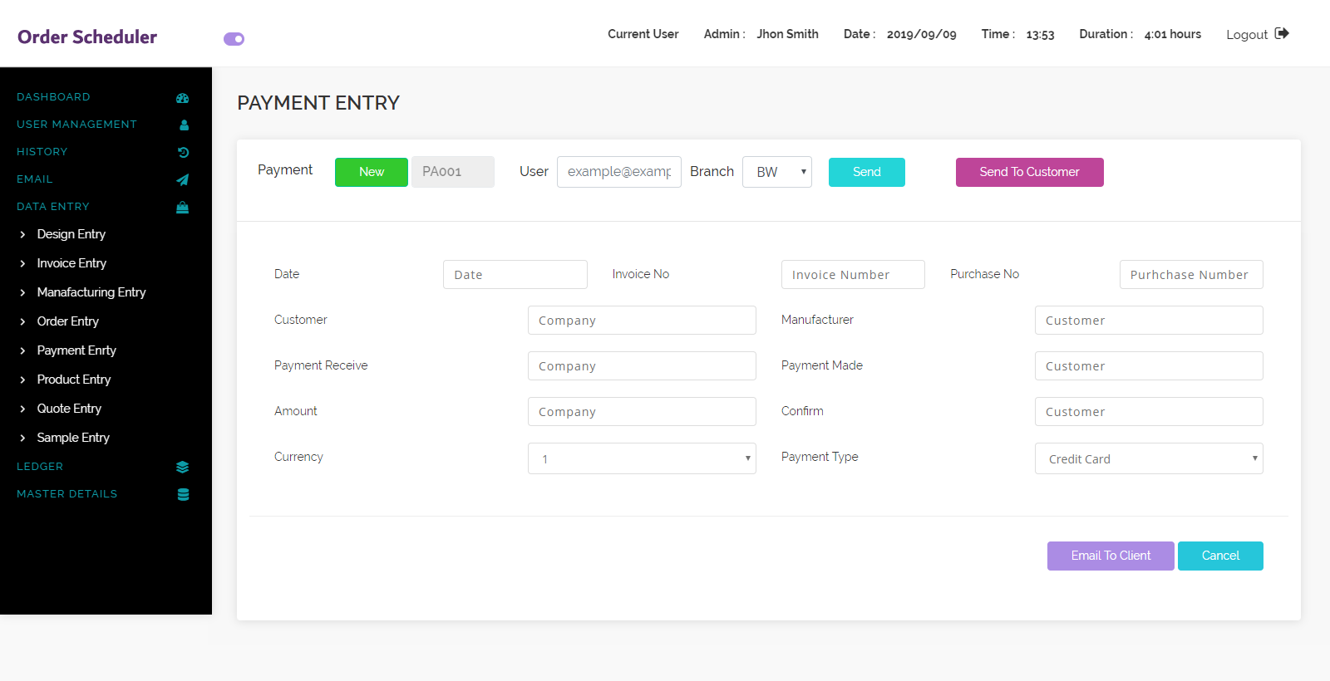

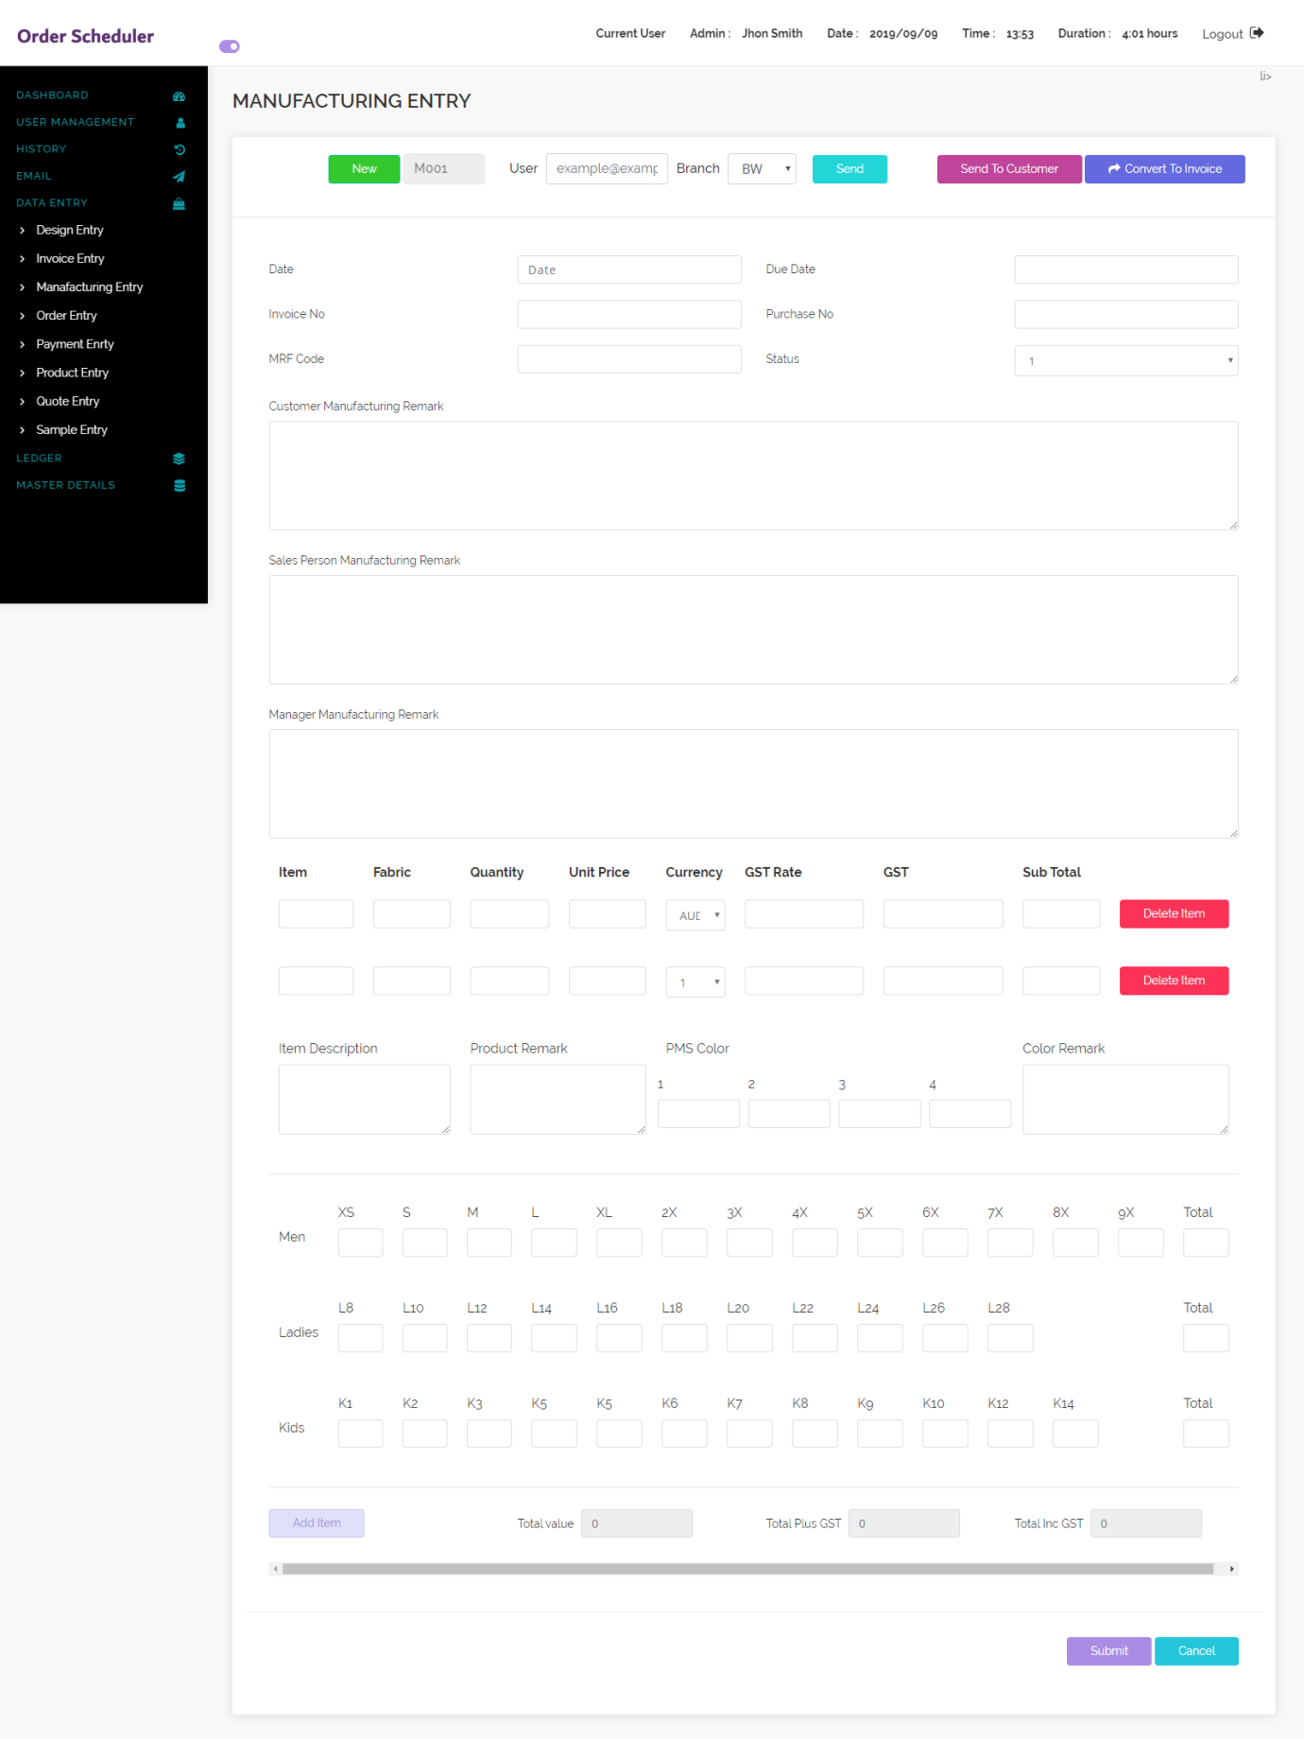

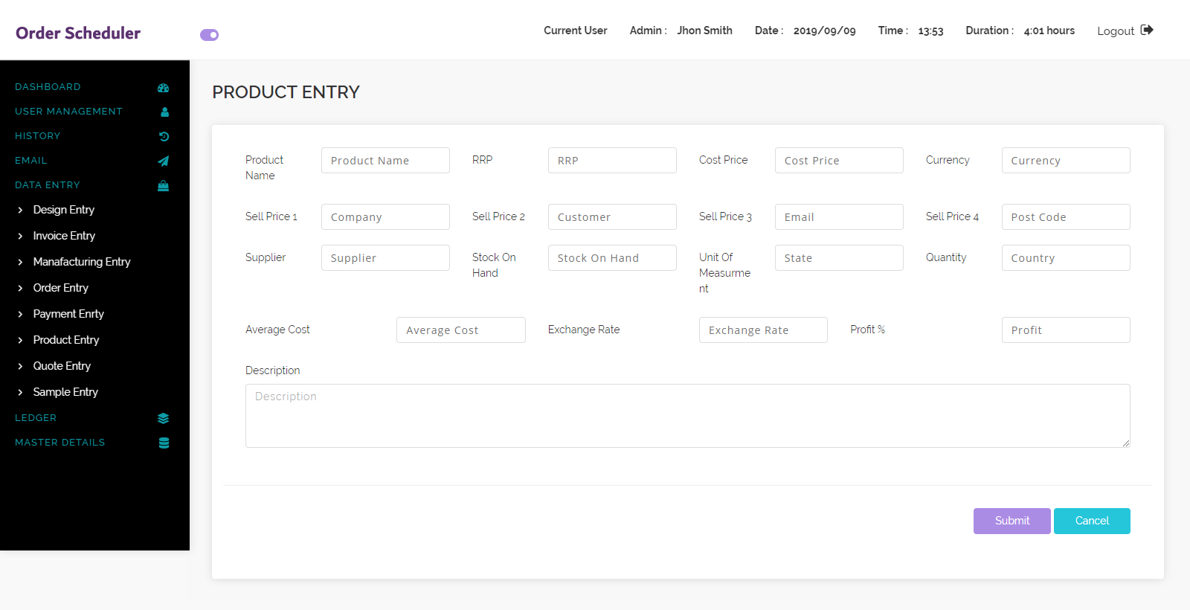

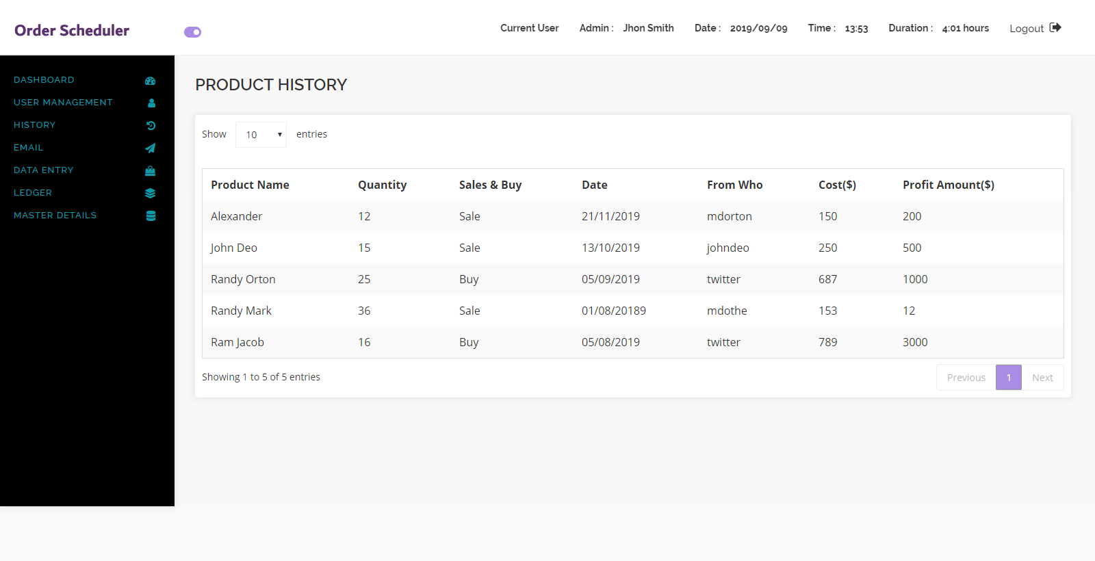

**Qty**

**History sales and buying**

**Profit amount in $**

**Add view omit for each line this should be on every ledger format**

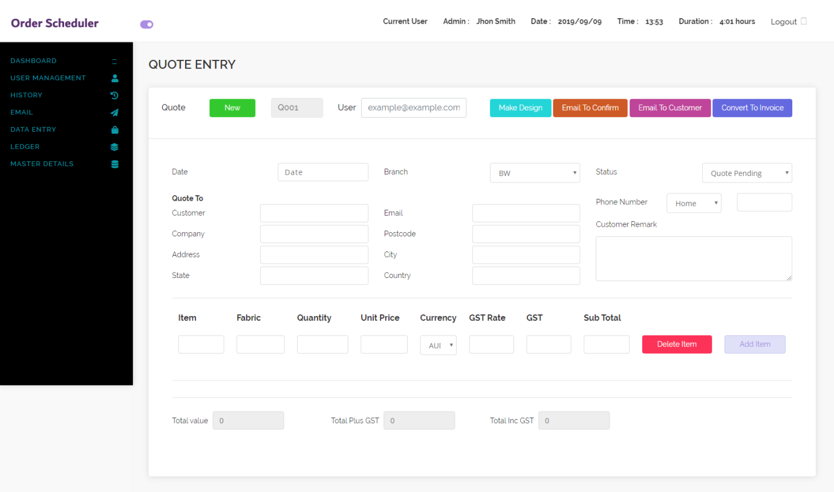

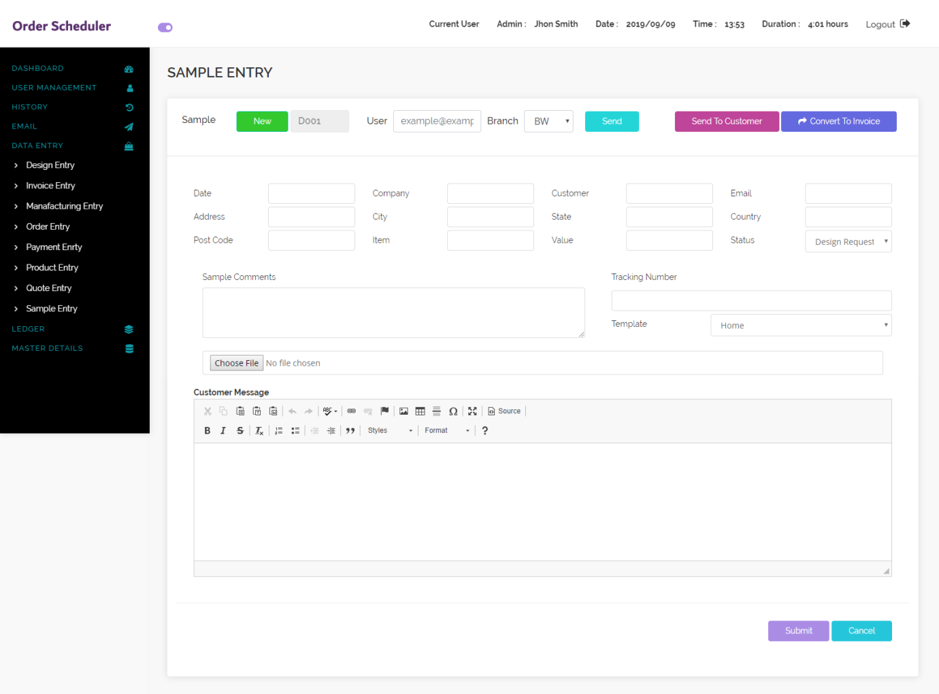

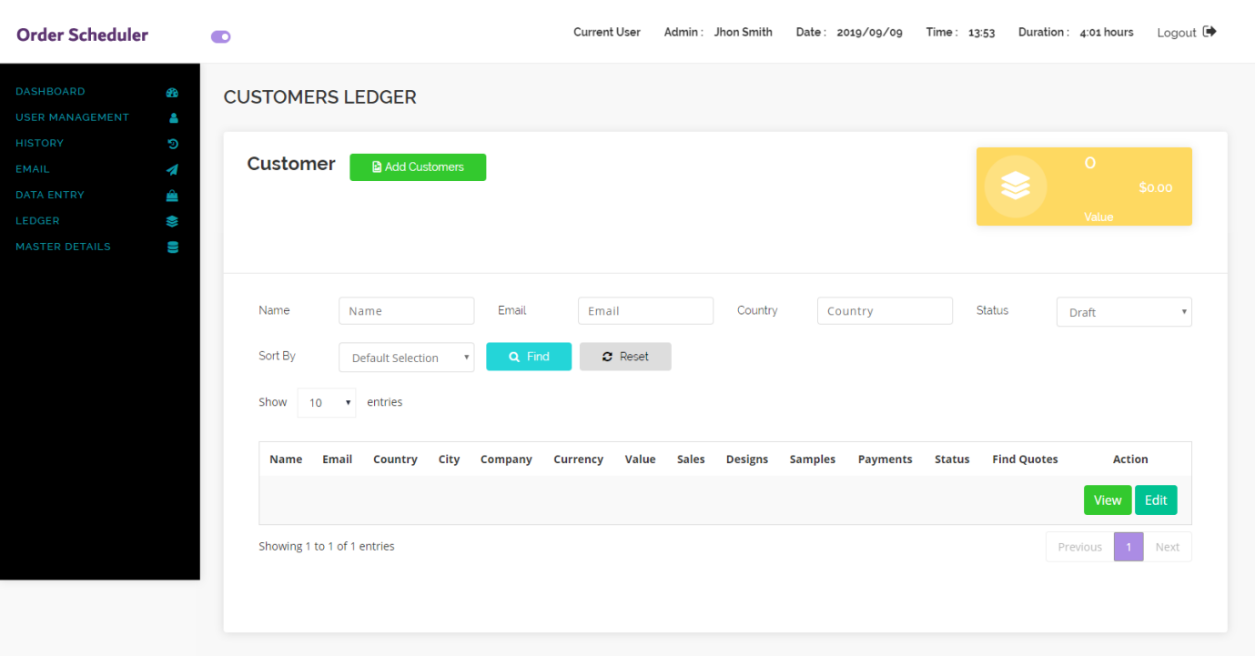

**Make sure colour yellow box is same as dashboard on all layouts**

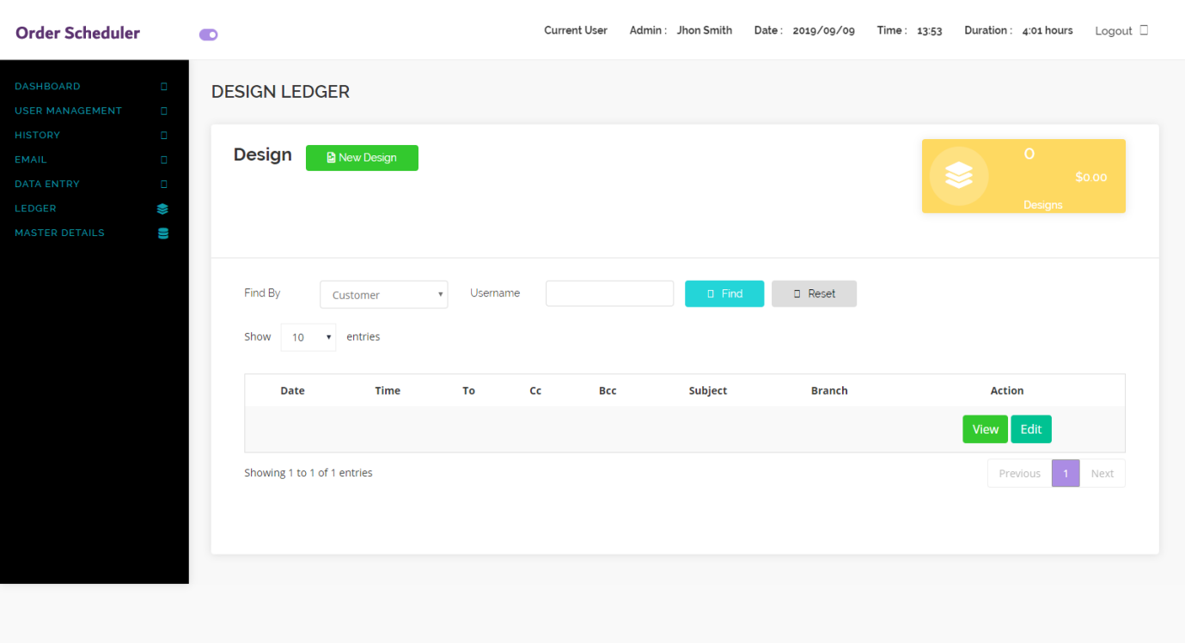

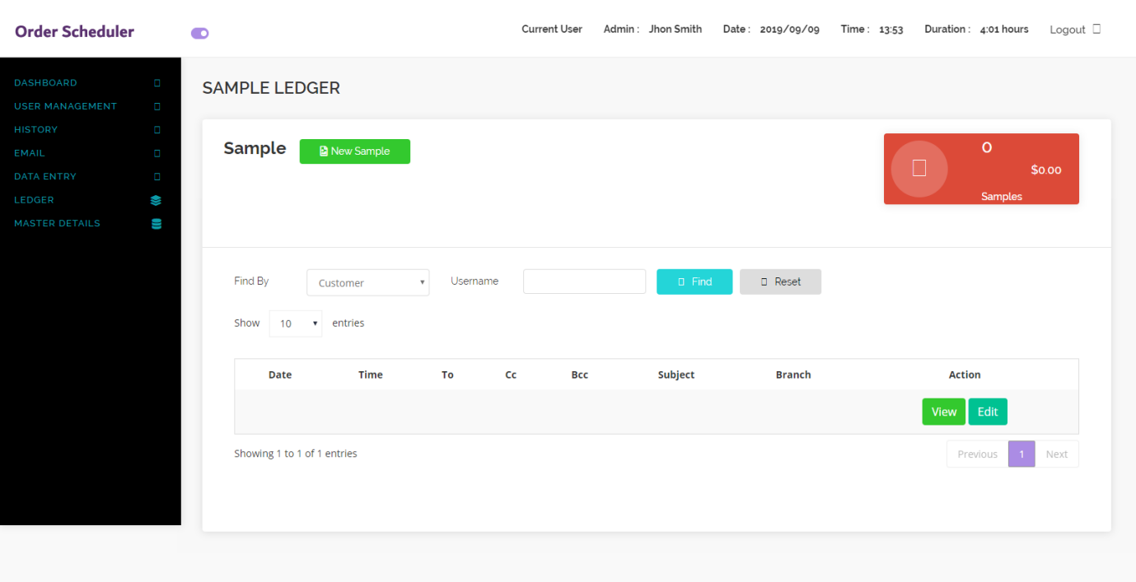

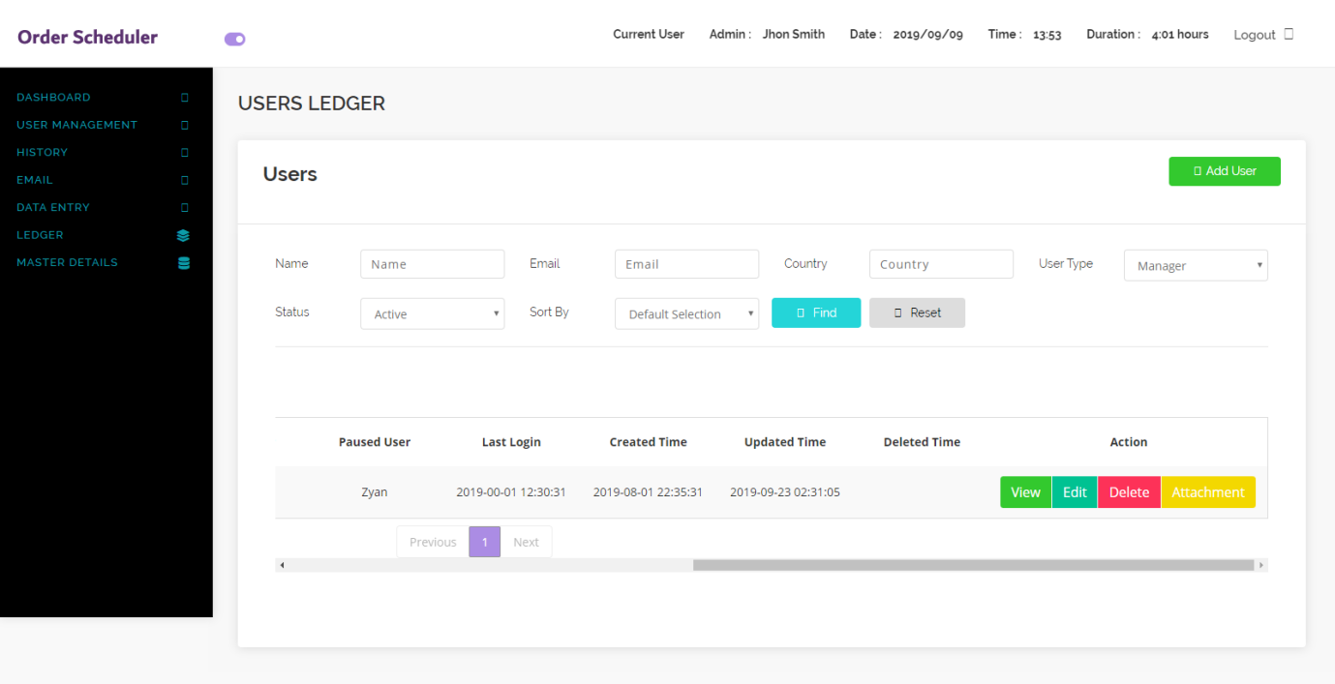

**MASTER LAYOUT**

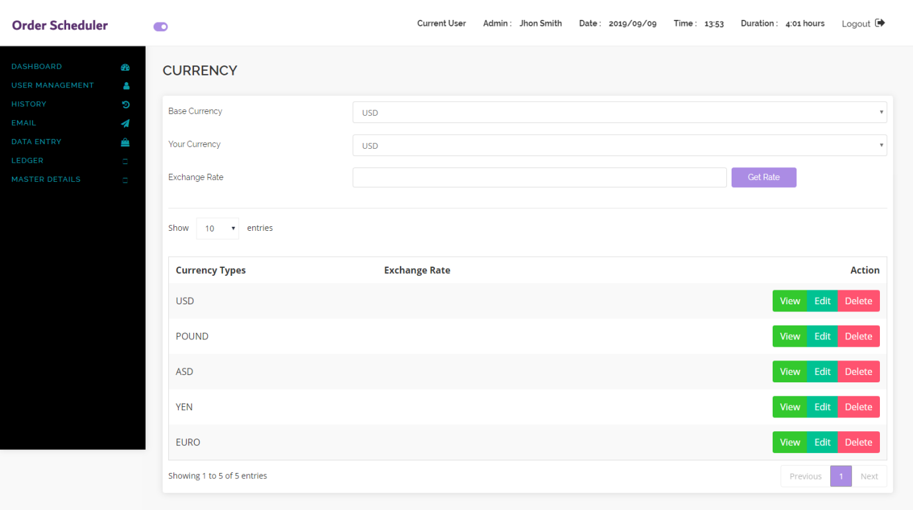

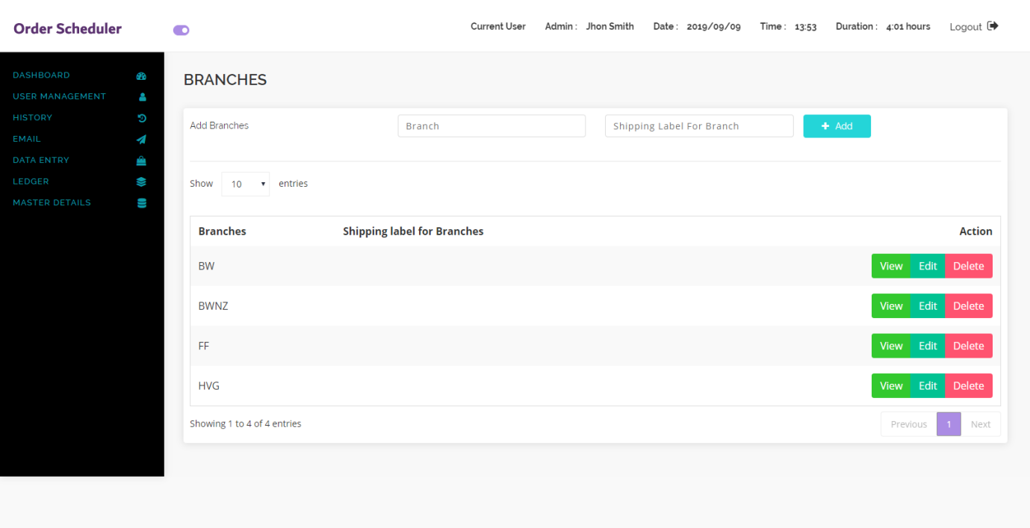

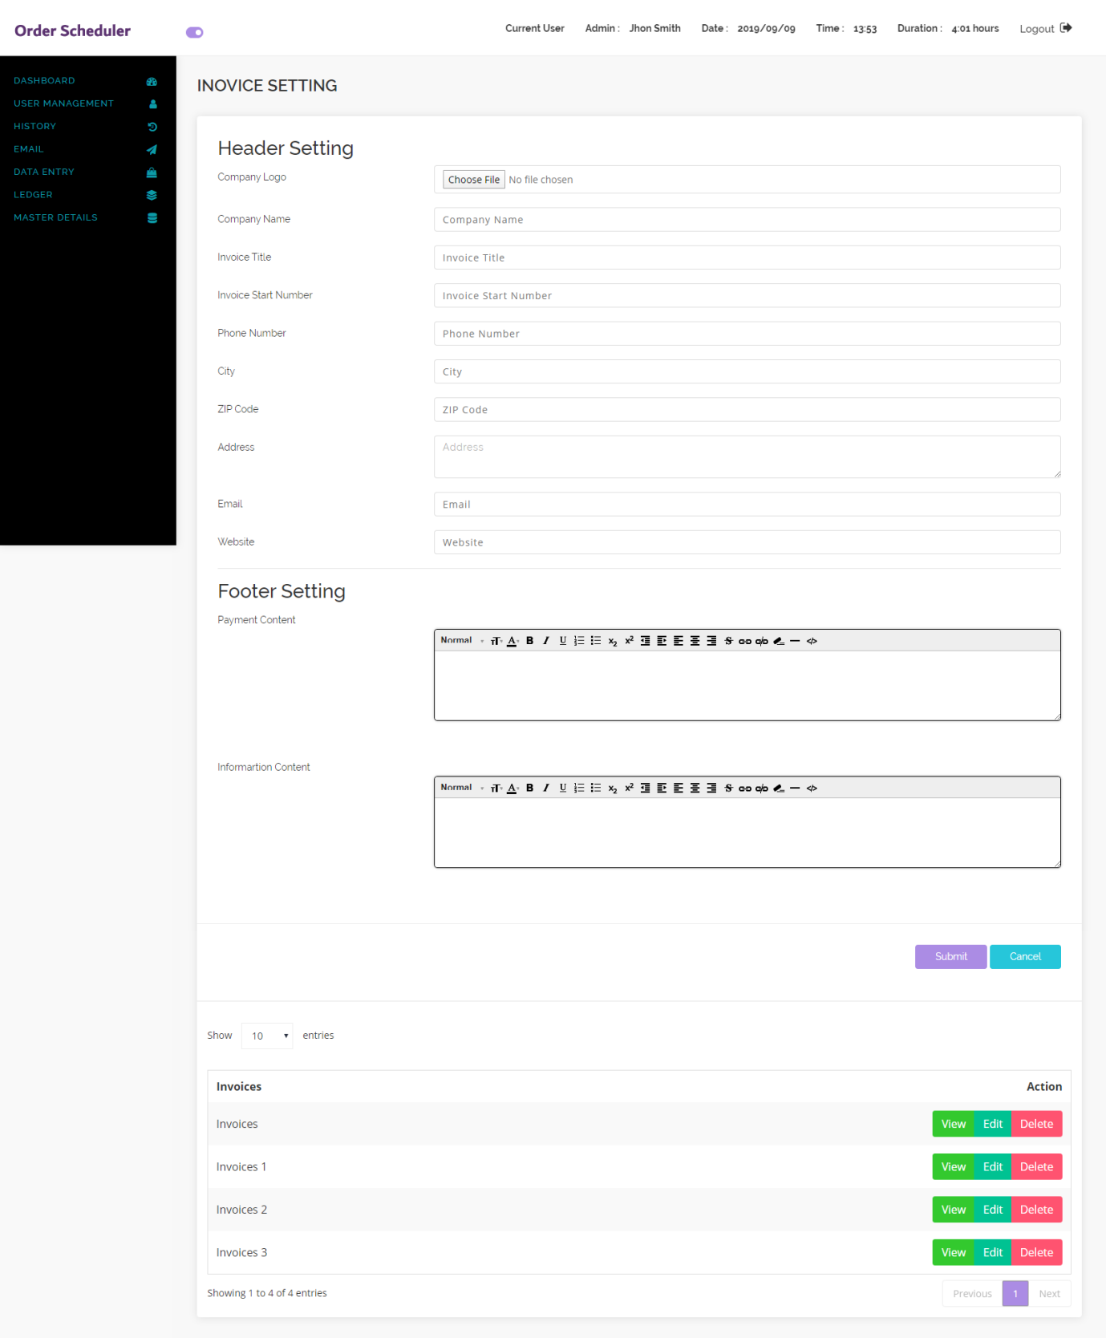

**please ensure all layouts are listed in the main user layout and a screen view of each layout is here**